Frontpage: https://supply-chain-blockchain-nine.vercel.app/
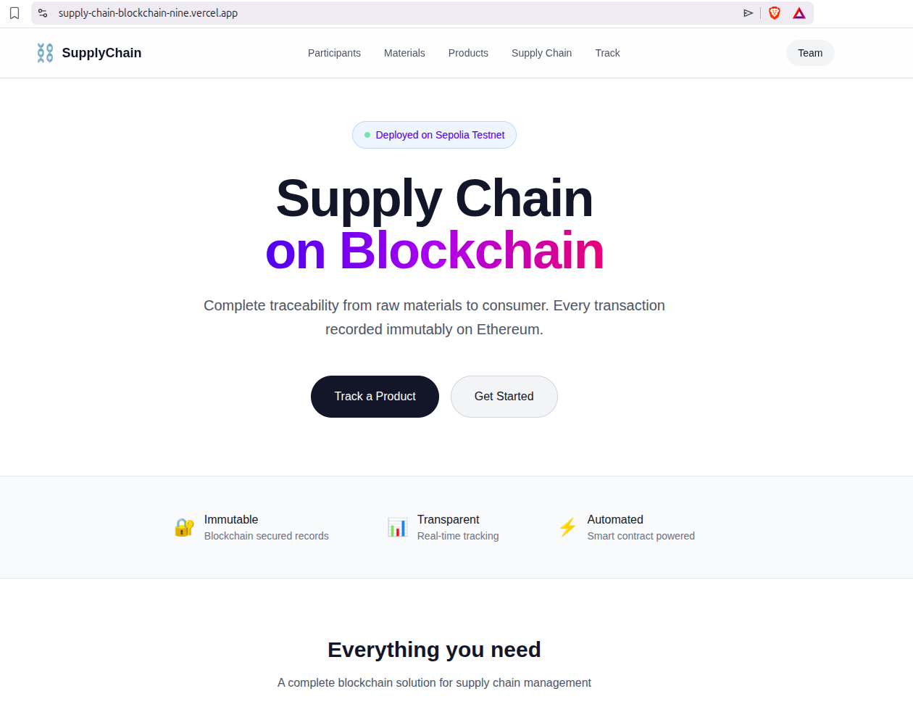

Roles: https://supply-chain-blockchain-nine.vercel.app/roles
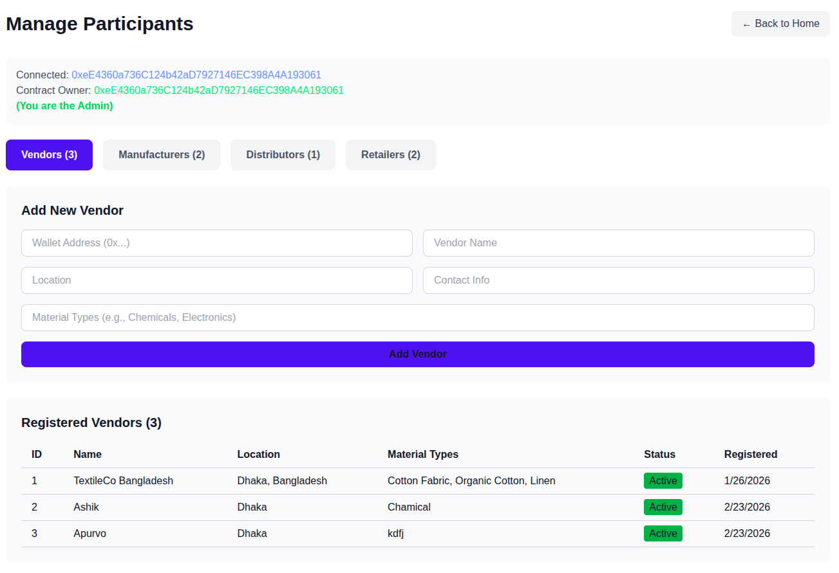

Adding material: https://supply-chain-blockchain-nine.vercel.app/materials
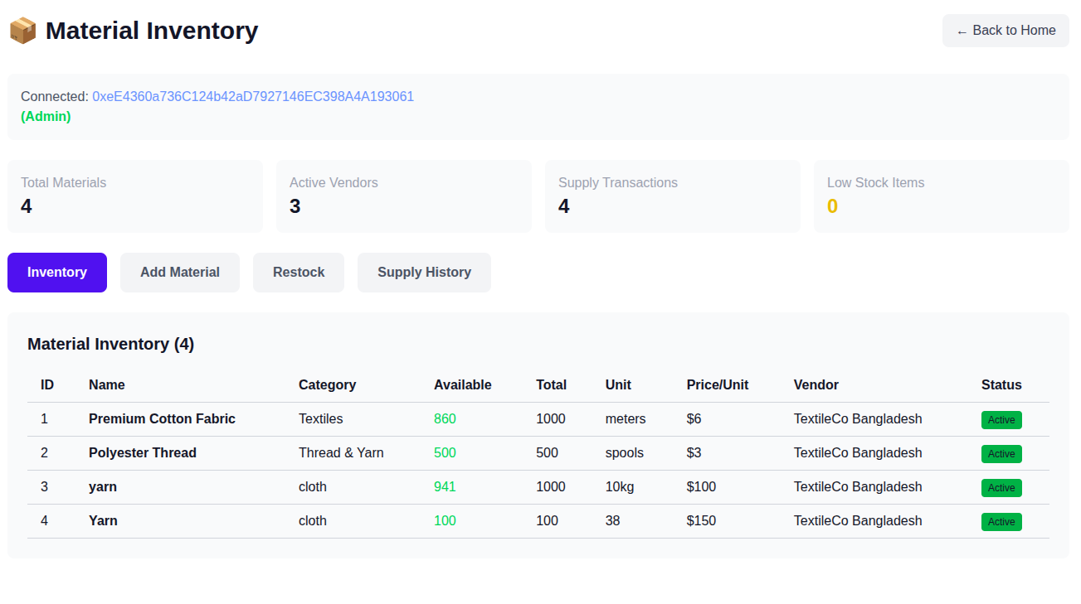
Adding new product; https://supply-chain-blockchain-nine.vercel.app/addmed
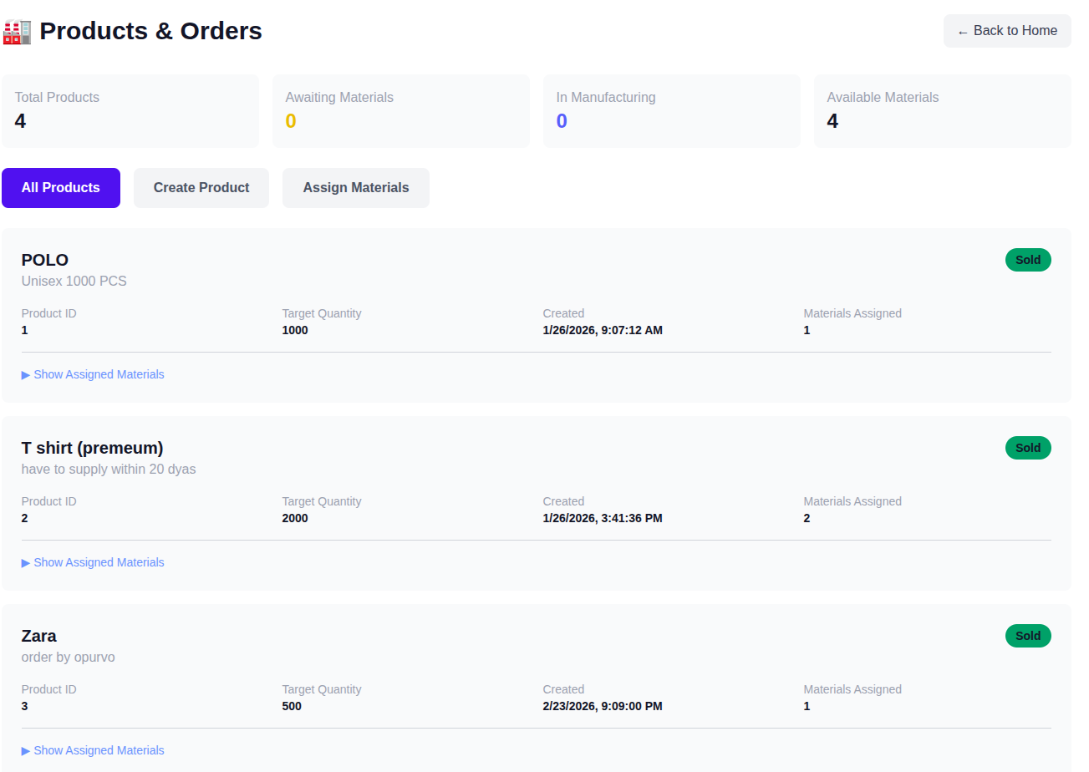

Role based Supply view: https://supply-chain-blockchain-nine.vercel.app/supply
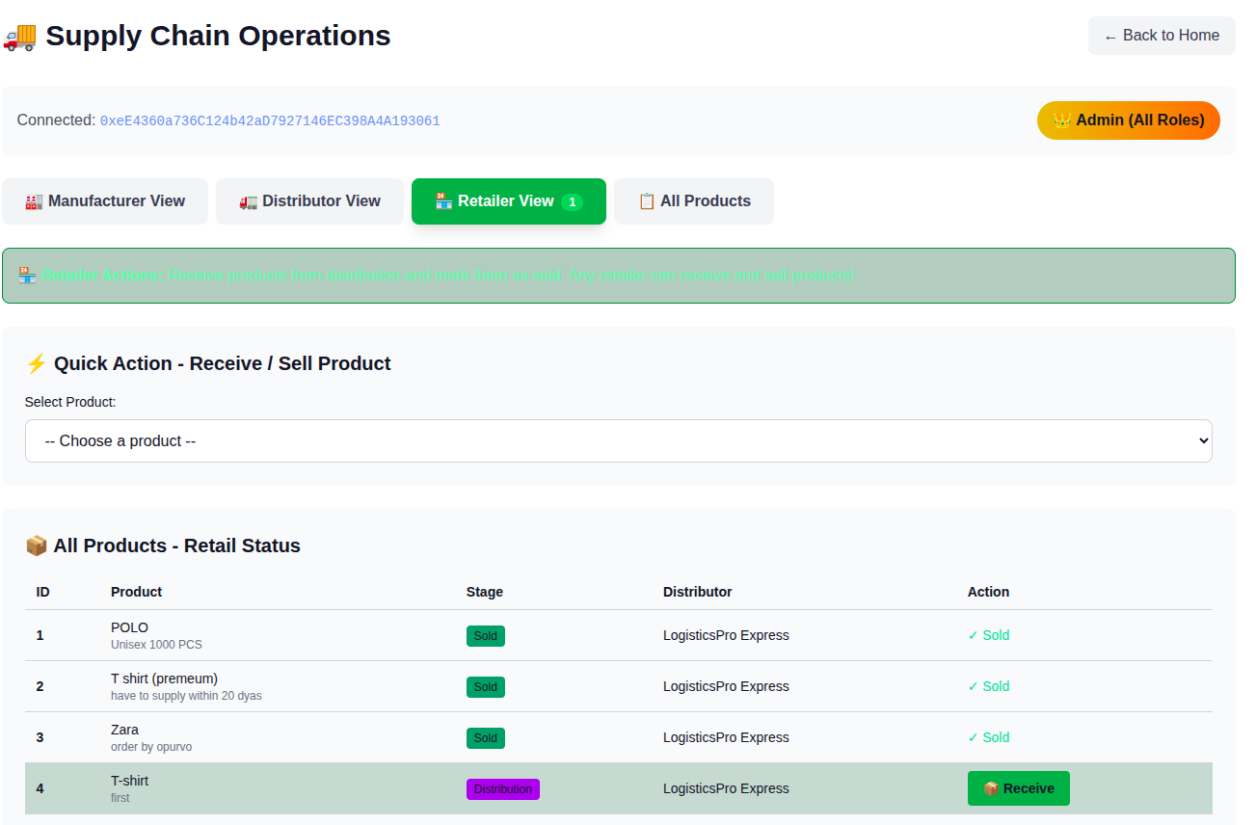

Tracking product;https://supply-chain-blockchain-nine.vercel.app/track
